Autumn Opera Scenes 2023
USC Exit
USR Prop table
House structure
Piano
DSL Door
DSR door
USL door
USR door
Important information
-It is mandatory to wear steelies in this role.
-The USR prop table is located in SR of the crossover corridor behind the stage
- Please use the door to the right when paging doors
-Door to US crossover is very loud do not let slam

Stage diagram

Preshow call- 16.00
Half call- 18.25
Quarter call- 18.20
5-minute call- 18.50
Beginners- 18.55
Start of show- 19.00
Director- Martin Lloyd-Evans
Designer- Nate Gibbon
Stage manager- Callum Wallace
Deputy stage manager- Ida Pontoppidan
ASMs- Rebekah Tunnell (USR), Jan Robotycki (USL), Brook Richardson (DSR), Ella Goldsworthy (DSL)

USR ASM Running list

When | What | Who | where | Notes
Pre-show
Start of call  4PM | Collect comms | USR ASM | flight case in the USR of the crossover | Labelled Bekah
3 Hours before show | Ensure the correct running props are in USR wing | USR ASM | USR props table | Only popcorn
3 Hours before show | Complete a stage sweep | All ASMs | On stage | As thorough as possible as there are bare feet on stage
Follow on | Mop the stage | All ASMs | On stage | Ensure warning signage is there to note slippery floor
2 hours 30 minutes before show | Complete reset and shout check | All ASMs | On stage | USR setting list is available in USR ASM folder  Full setting list on ASM paperwork
Half call | Put popcorn in the popcorn bucket | USR ASM | USR prop table | Split entire bag between 3 buckets
On FOH clearance | Move Yellow flight case | USR and DSR ASM | USR Prop table to DSR wing
Prologue
Beginners call | Check that USR beginners are present | USR ASM  Rosalinde | USR Door | The only beginner in this wing is Rosalinde
Die Fledermaus
5 mins in  (start of dialogue) | Page door for Rosalinda Entrance | USR ASM  Rosalinde | USR Door | On green cue light
13 mins in  End of Piece | Page door for Entrance | USR ASM  Federica | USR Door | On green cue light
Louisa Miler
15 mins in During Louisa Miller | Check that Susanna has the Figaro Props | USR ASM | USR wing | It will be the laundry basket and engagement ring from the USR prop table.  Check that the pink throw is inside the laundry basket alongside the clothing, including a red bra.  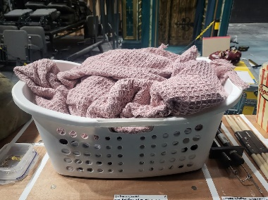
21 mins in  End of Piece | Page door for Entrance | USR ASM  Susanna | USR Door | On green cue light
Le Nozze De Figaro
35 Mins In  End of Piece | Page door for Exit | USR ASM  Susanna | USR Door
Hamlet
37 mins in  Start of piece | Remove comms | USR ASM | USR wing | Let SM ring know you are off comms and leave them on music stand
38 Mins in During hamlet | Enter the house with blue chair | USR and DSR ASM | USC entrance into the house structure | Chair is found in USR props area. Put into SL of the house.
When Hansel arrives | Prepare the wheelie bin | USR and DSR ASM  Hansel | Inside the house structure | Move bin to SL of the house next to the chair. Open the lid and hold the handles to steady the bin while Performer enters.
42 mins in  End of piece | Page door for Bin | USR and DSR ASM | Inside house structure | On green cue light, open the door so that DSR ASM can wheel the bin to the spike marks on stage.  Leave the door open
Follow on | Lower bin onto its side | USR and DSR ASM | USR (bin on spike marks) | Foot bin with right foot and hold corners of bin do not use the handle.  Slowly lower the bin onto the side with the handle facing downwards.
46 mins in Follow on | Leave the stage and put comms back on | USR and DSR ASM | USR to USC exit to USR wing | Close the door behind you then exit through the USC exit  Let the SM ring know you are back on comms
Hansel and Grettel
Visual cue Azael moves to USR  50 mins in | Page door for Exit | USR ASM  Azael | USR wing
56 mins in | Go to house to prepare for interval | USR ASM | USR wing to USC entrance | Meet rest of the ASMs and SM to enter through the USC entrance at the start of the interval
Interval (20 mins long)

1.5 mins into interval | Strike whiskey tray | USR ASM | Through USC entrance to CS back through USC Entrance
Follow on | Strike table | USR ASM  DSL ASM | Through USL entrance to CS | This is a 2-person lift  Ensure correct manual handling procedure
Prologue
Visual cue Azael moves USR  1 hour 25 mins in | Page door for Azael Exit | USR ASM  Azael | USR Door
Carmen
L’Enfant
Start of piece  1 hour 32 mins in | Page door for Azael Entrance | USR ASM  Azael | USR Door | On Green Cue light
During L’Enfant  1 hour 33 mins in | Move operating table to the DSR wing | USR and DSR ASM | USR prop table to DSR wing | Make sure breaks are all off before moving.  Set the table with the light closer to the door and the white sheet should be accordion folded with the corner easy to reach.  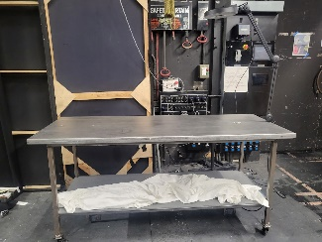
Follow on | Move Cinema seats and 3 popcorn buckets to the USR wing | USR and DSR ASM | USR props table to USR wing | Ensure white sheet is on top of the seats and 2x angel wings are set on top of that  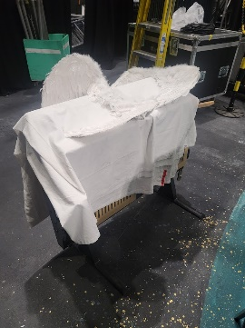
End of piece  1 hour 45 mins in | Page door for Entrance | USR and DSR ASM  2x Performers in scrubs | DSR Door | Page the right door.  Other ASM will do the other
Don Pasquale
End of piece  1 hour 55 mins in | Page door for Entrance for cinema seats | USR ASM  2x angels | USR Door | On green Cue light, open one door until it latches onto the Magnet that holds it and hold the other open. Once the cinema seats and performers are on, close the door held open, and press the red button on a white box at the top of the door to release the other and close as fast as possible.  Keep door slightly open to watch for next cue
Visual cue angels and patient go to USR  1 hour 56 mins in | Page door for Exit | USR ASM  2x angels and patient | USR door
Beatrice and Benedict
Top of piece  1 hour 56 mins in | Page door For Entrance | USR ASM  Cinema guests x2 | USR Door | On green cue light, you will be on the same standby for the next 3 cues  Ensure they each have a popcorn bucket
1 hour 56 mins in | Page door for entrance | USR ASM  Beatrice | USR Door | On green cue light  Ensure she has popcorn bucket
1 hour 57 mins in | Page door for Benedict Entrance | USR ASM  Benedict | USR Door | On green cue light  Ensure he has army duffel bag  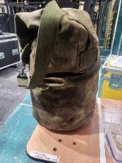
End of piece  2 hours in | Page door for Entrance and exit | USR ASM  2x performers | USR Door | Page door for entrance and then open one door until it latches onto the Magnet that holds it and hold the other open. Once they have brought the chairs through, close the door held open, and press the red button on a white box at the top of the door to release the other and close as fast as possible.
La Boheme
During piece  2 hours 3 mins in | Take cinema seats to USR props table | USR and DSR ASM | USR wing to USR props table | 2 person lift  Use correct manual handling techniques
2 hours 4 mins in | Ensure spinning wheel and stool are DSR wing | USR and DSR ASM | USR to DSR wing | 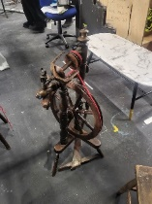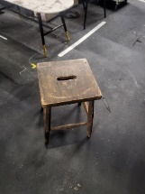
2 hours 5 mins | Take operating table to USR props table | USR and DSR ASM | DSR wing to USR props table | Be as quiet as possible  Be careful of the wheels on the ledge into the crossover
Rape of Lucretia
2 hours 7 mins in | Page door for Entrance | USR ASM  Lucretia | USR Wing | Ensure she has embroidery hoop prop  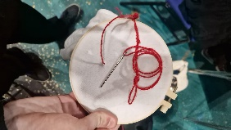
Bows
2 hours 20 mins in | Page door for entrance | USR ASM  Josh  Karima | USR wing | On green cue light
2 hours 25 mins in | Page door for exit | USR ASM  Marianna  Tom  Sang | USR wing | On green cue light
Post-show
After the audience has left the auditorium | Sweep up the popcorn on the stage | USR ASM | USC of the stage
End of call

